HYDROMODPY - PRESENTATION

HydrModPy is a code especially created to run MODFLOW model at the watershed scale. There is a lot of class and function, from watershed extraction to the multi-objective calibration.
Legend in this document
FOLDER
DOC
SCRIPT
CLASS
DATA
RESULTS
How structure a Python project :
- https://docs.python-guide.org/writing/structure/
- https://github.com/pypa/sampleproject

Access the Git
https://gitlab.com/Alex-Gauvain/HydroModPy
ATTENTION
2 branches
master
the last updated and the more “stable” version, but not necessarly the best
dev
the branch in dveloppement, should still work, the one with the most novelty, maybe the most user friendly

Inside the Git
In the repository “HydroModPy” :
CORE_COMM : all the HydroModPy class and functions in different folders
DEV_SPEC : a folder by user, not used these last times, because now we work on dev branch on the CORE-COMM
docs
source
scripts with “.rst” format : fill this files for the Read the Docs
conf.py : configuration of the web site Read the Docs
readthedocs
readthedocs_notes.txt : files with some notes about readthedocs
readthedocs_requirements.txt : files with some resquirements about readthedocs
.readthedocs.yaml

Read the Docs
Documentation ReadTheDocs
https://hydromod.readthedocs.io/en/latest/
Example on ReadTheDocs
https://hydromod.readthedocs.io/en/latest/examples.html

General structure
CORE_COMM

.ipynb_checkpoints : intially for jupyter notebook files “.ipynb”
_pycache_ : generated automatically, necessary ?

calibration : functions for the multi-objectve calibration
diagram : visual diagram of hydromodp functions
examples : examples or run/launcher scripts created by different users
groundwater_flow : scripts that permit to develop models
interface : codes to develop interface click/buttons
readme : informations about installation and environement
surface_flow : a code for surface flow routing
tools : created simple toolbox for repeated actions
watershed : the heart of hydromodpy, create a watershed object (extract data, parametrization, run)
In order to extract a watershed, run a model MODFLOW or the calibration, the user just need to develop a script, recommended in the “examples” folder, and call the different classes and functions in the other folders and scripts.
Below is a brief and rapid overview of the 9 FOLDERS of fnctions and class in the CORE_COMM :
The chosen order of explanation is both according to importance but also somewhat chronological
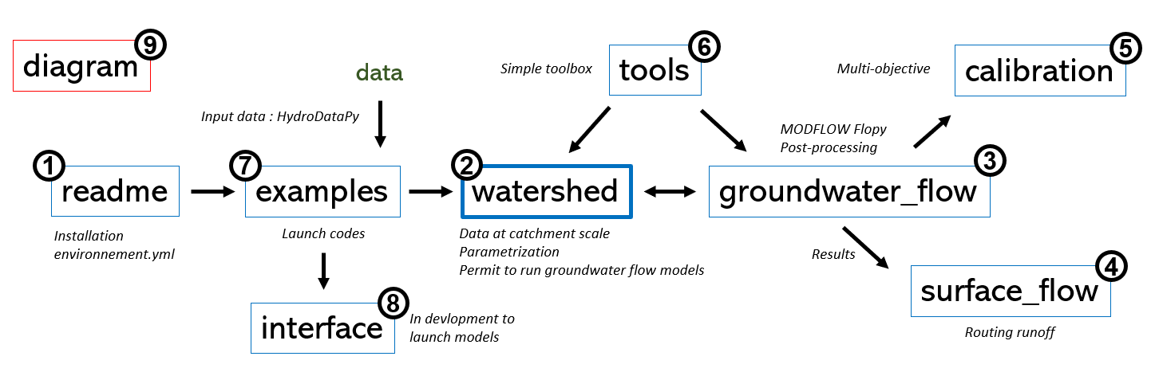

readme

watershed

groundwater_flow

surface_flow

calibration

tools

examples

interface

diagram

Launch something

Input data
(“personal” configuration”)

Output data
(“proposed” configuration)
You choose a output path : “D:/…”
Cheze : the name of the watershed : example ‘Cheze’
results_calibration
calib_dicot_hom_1v_k1 : folder with results of the calibration (calib_method_type_count_variables)
streams_calibration : labelled according to the source data (piezometry, streams, hydrometry)
There is MODFLOW raw results, and depending the calibration, some files results (‘.tifs’)
calib_dicot_hom_1v_k1_2022-07-20_21h28m09s.calib : all calib results inside
calib_dicot_hom_1v_k1.csv : choosen parameters of the calibration
Cheze_koptims_dichotomy_streams.csv : recapitulative objective function results of the calibration
results_simulations
calib-test-v1_1_REC-REA-historic_2.0-3.89-30_1978-2019 : name of the model
_watershed
_tifs : results in ‘.tifs’ format, georeferenced
_simulated_results.csv : results at the catchment scale (averaged or cumulated)
seepage_areas.npy : results ‘.npy’ format, a hierarchical file, a 2D matrix for each time step
list of all raw MODFLOW results
resultls_stable : a folder with all data clipped at the catchment scale (geography, climate, hydrology…)
python_object : the watershed object created and/or loaded, with a lot of caracteristics inside

